Land South of Bungay Road, Scole

- Hopkins Homes are providing this consultation response in reply to the Regulation 18 Consultation of the emerging South Norfolk Village Clusters Housing Allocations Document by the requested site submission deadline of 2nd August 2021.

- Hopkins Homes Ltd is the largest independent house building company in East Anglia with a reputation for delivering well designed, high quality residential and mixed-use development harmonising with its local context. In the past decade the company has succeeded in delivering sustainable developments which improve neighbourhoods, improve local infrastructure and add to local distinctiveness throughout the Greater Norwich area.

- Hopkins Homes are planning positively to deliver the residential development of 8.22 Ha of land South of Bungay Road, Scole. The land the is the subject of an option agreement between the landowners and Hopkins Homes Ltd. which seeks to promote and deliver a residentially-led development of the site of up to 160 dwellings, together with up to 3 Ha of associated public open space.
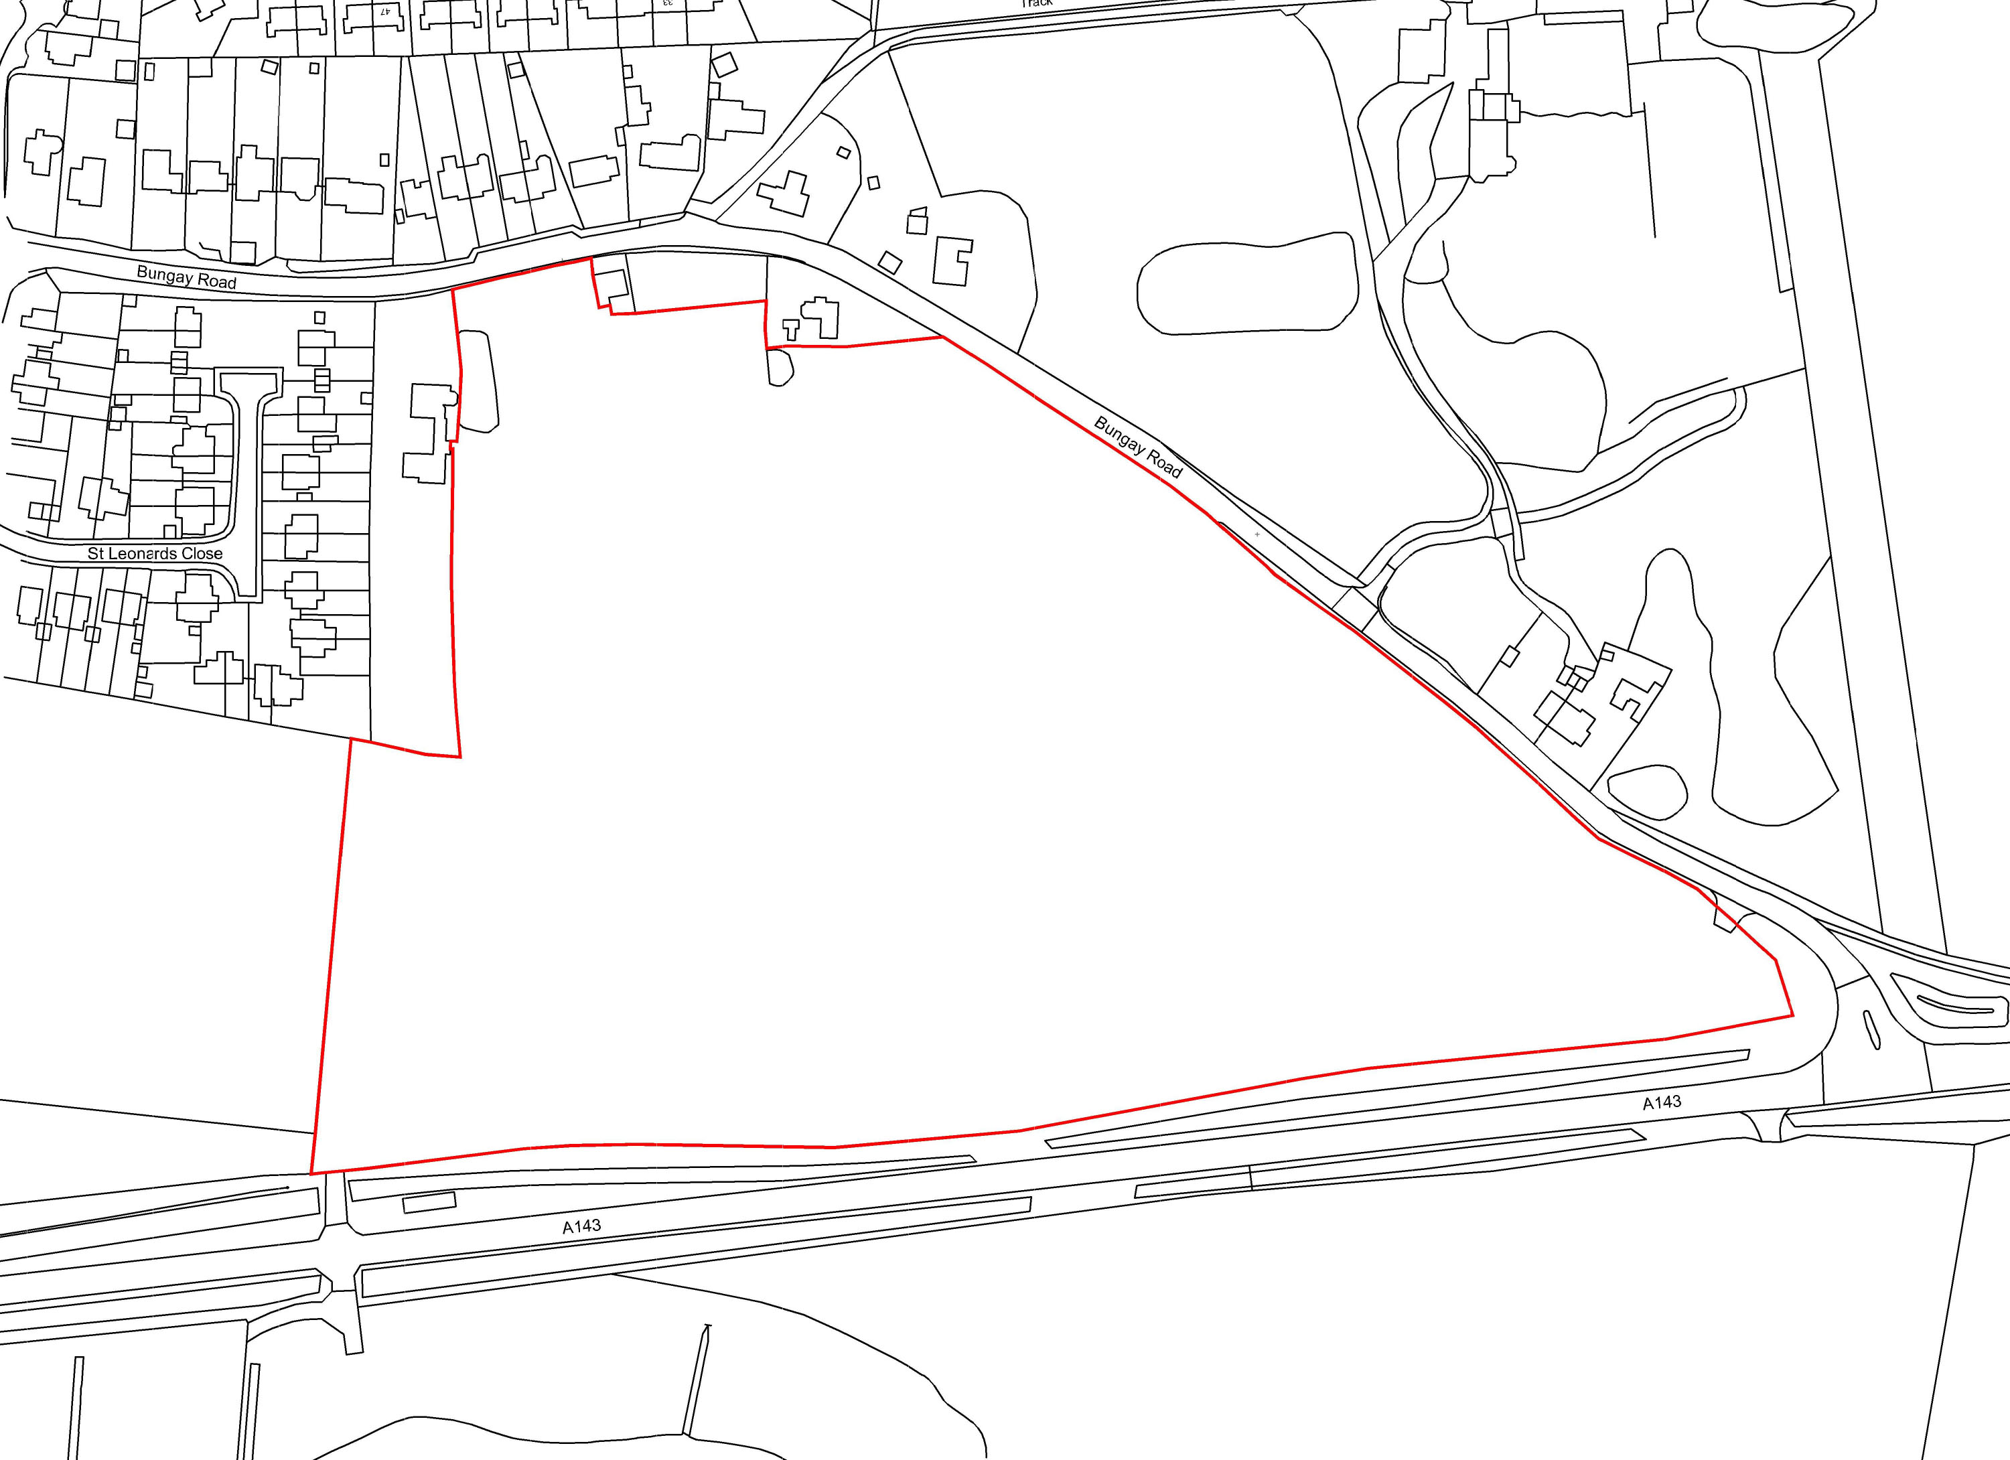

- The site is confirmed as being deliverable in that it is available now, in a suitable location and achievable with a realistic prospect of development being delivered well within the next 5 years.

- Scole is sustainable as a location for new development. It has a population of close to 1,400 residents and approaching 600 dwellings. The village is well served by local education, sports and community facilities with good transport links to the nearby market town of Diss. The current local plan would see only 20 homes added to the housing stock over a 15-year period and this must be regarded as disproportionately low in the context of the growth aspirations of the Greater Norwich region in general.

- Whilst planning application timeframes would need to be further discussed with the District Council having regard to the Local Plan progress, theoretically, Hopkins Homes Ltd could progress an application on this site without delay, such that it could assist housing delivery within the next five years (with a projected delivery of 45 homes per full year).

- We are aware that the proposed site allocations for Scole are suggested to be deferred to the emerging Diss & District Neighbourhood Plan, and whilst we are in dialogue with both Scole Parish Council and the Neighbourhood Plan Steering Group regarding potential development options, we consider that the Plan’s current strategy is unsound, on the basis that it does not contribute towards the achievement of sustainable development, nor is it positively prepared in a way which is aspirational but deliverable.
- The NPPF 2021 makes it clear at Paragraph 71 that ‘Planning policies should identify opportunities for villages to grow and thrive, especially where this will support local services’.
- The current strategy of this Clusters Plan to identify sites to accommodate at least 1200 dwellings is derived and driven by that of the over-arching Greater Norwich Local Plan, which itself is yet to be Examined, hence is highly likely to be subject to further change. As such, we have serious concerns regarding the lack of transparency or evidence-based assessment as to how the levels of growth proposed to be apportioned to respective settlement cluster were made. To this end, we would strongly recommend that further evidence is provided as to why each settlement cluster has been apportioned the number of dwellings currently proposed, and not more or less.
- In respect of Scole, whilst we are clearly supportive of further growth, we object to the very limited level currently being proposed, hence are unclear as to why only 25 dwellings are being proposed for allocation ? Scole has been previously classified as a ‘Service Village’ but it more readily functions as a ‘Key Service Centre’ village, whereby day to day services and facilities are close at hand. Development here would be in tune with the Core Planning Principles of the NPPF.
- The Sustainability Appraisal which accompanies the Draft Plan appears to have been constrained by the desire to seek allocations of 50 dwellings or less, such that there appears no consideration of alternative options to deliver the minimum requirement of 1200 dwellings - a requirement which in itself may increase depending upon the outcome of the GNLP Examination. This appears to be a major flaw in the overall assessment of the most sustainable way to deliver the required minimum levels of growth.
- There is also the clear risk that in only identifying sites of between 15 and 50 dwellings, the Plan will fail to address the defined key objectives of meeting housing needs and a mix of housetypes, including affordable housing, together with the associated infrastructure requirements. The viability and deliverability of such small sites is highly questionable, such that greater flexibility in site size is required. Larger sites in the proportionately larger villages such as Scole are therefore required to provide just such flexibility and ensure that the key Plan objectives can be met. In this instance, the allocation of the Bungay Road site, as part of the wider development strategy of the Plan, would go some way to providing certainty that an appropriate and deliverable housing location, in the control of a housing developer, can come forward.
- The growth distribution bias of the Plan should be moved further towards villages, in order to facilitate growth, in the short to medium term, at places such as Scole, where community infrastructure, services and facilities are already in place and can be readily improved. This would assist with removing the risk of sustained periods of lack of housing supply, as has previously persisted throughout South Norfolk and the wider Greater Norwich Plan area.
- The location of the site to the south-east of the village is identified on the attached plan. The site is bordered by existing residential development to the north and west, with the existing A143 bypass running to the south, enabling the site to form a natural extension to the existing built form of the village with minimal impact upon the wider rural landscape beyond.
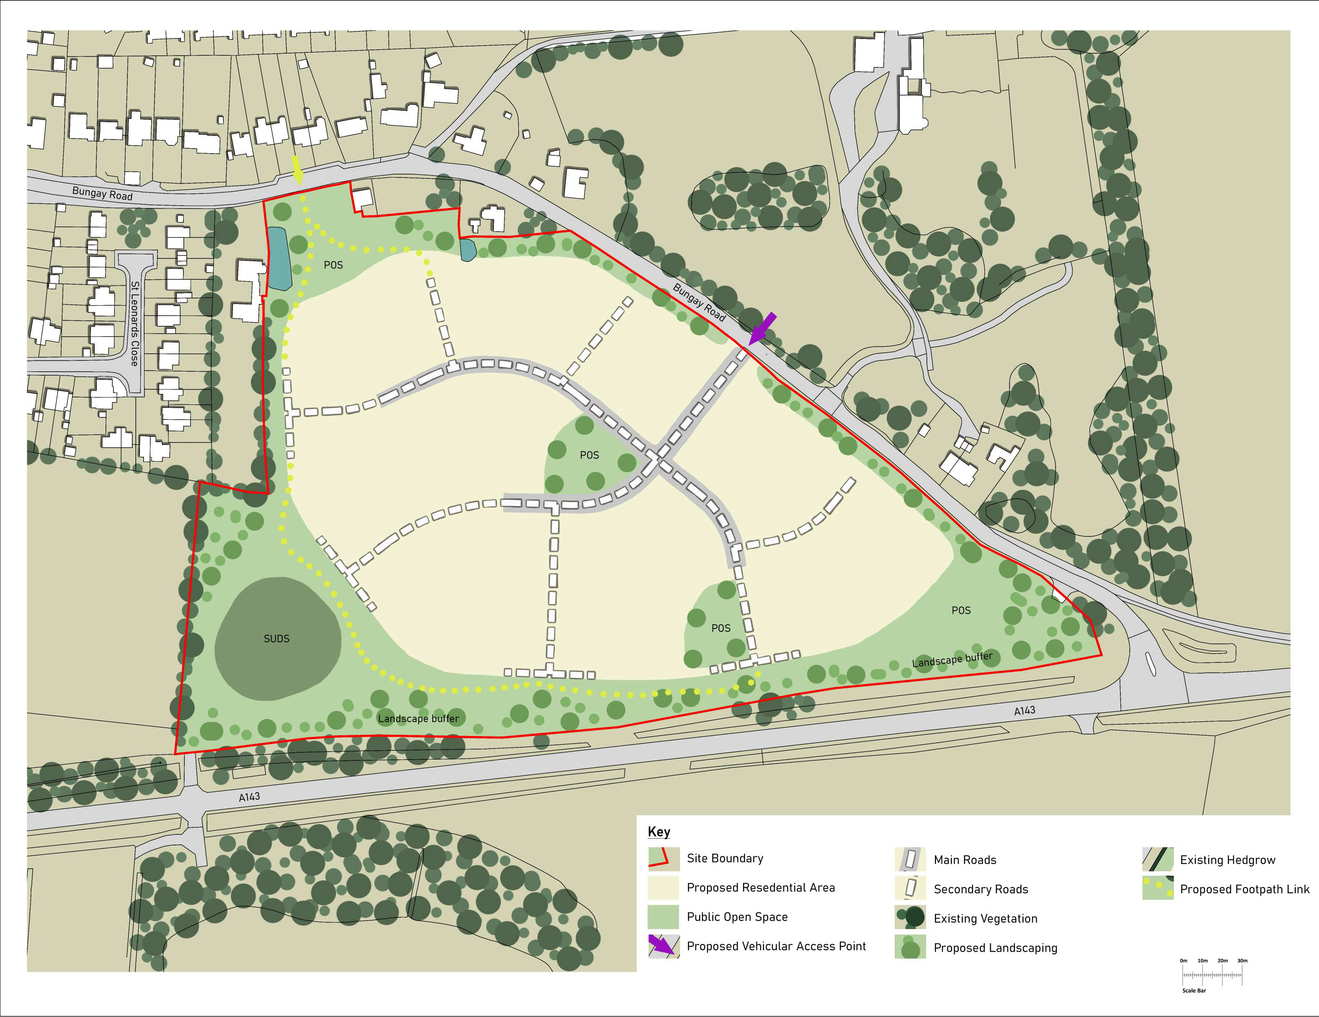
- In relation to biodiversity impacts, Hopkins Homes would submit that the development could be beneficial, in that the biodiversity of the site is low and relatively benign at present. The new development would add planting and native landscaping which would aid biodiversity objectives.
- The site is within walking and cycling distance of key services, with the village benefitting from a Primary School, Village Hall, Public House and convenience store, with the market town of Diss less than two miles from the site.
- There are no drainage or physical infrastructure issues which cannot be overcome by standard engineering solutions, thus the site is demonstrably deliverable in a sustainable and technically appropriate manner.
- In conclusion, Hopkins Homes Ltd therefore requests that the site is proposed as a residential allocation within the emerging South Norfolk Village Clusters Housing Allocations Document, with the settlement limit for the village extended to encompass the totality of this site.

