Please follow this link https://www.inaturalist.org/observations/50984746
Common Spotted Orchid Dactylorhiza fuchsii
Research Grade
Follow
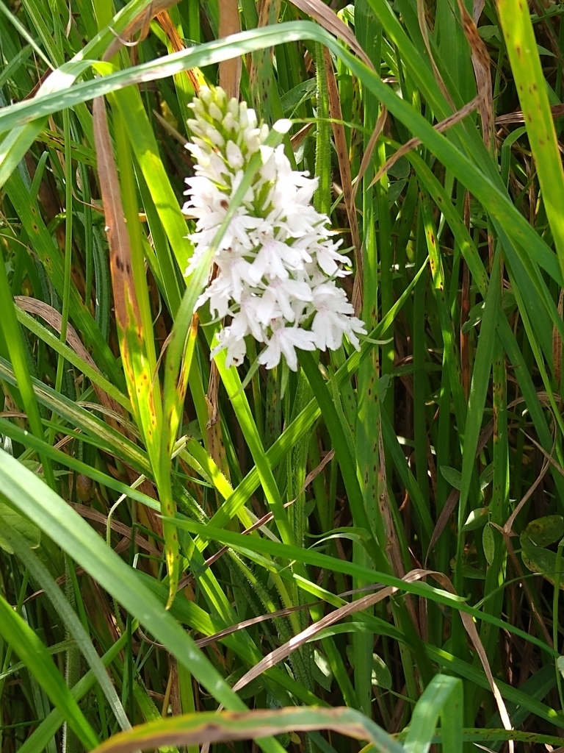
stuartellison

2 observations
Observed:Jun 26, 2020 · 13:54 CEST
Submitted:Jun 26, 2020 · 14:51

Map
Satellite
Overlays

Keyboard shortcuts
Map data ©2023 Google
20 km
Terms of Use
Norwich NR14 7UT, UK
Details

Activity
stuartellison suggested an ID ID Withdrawn3y
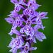Marsh OrchidsGenus Dactylorhiza
arethusa suggested an ID Improving3y
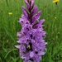Common Spotted OrchidDactylorhiza fuchsii
mercantour suggested an ID3y
Common Spotted OrchidDactylorhiza fuchsii
stuartellison suggested an ID3y
Common Spotted OrchidDactylorhiza fuchsii
- Comment
- Suggest an Identification
Log in or sign up to add comments.

Community TaxonWhat's this?
Common Spotted Orchid Dactylorhiza fuchsiiCumulative IDs: 3 of 3

0
2/3rds
3
Agree
About

Projects (1)
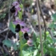
Wild Orchids of Western Palearctic

Top Identifiers of Common Spotted Orchid

Copyright Info and More
Observation © stuartellison · some rights reservedThis observation was created using:
iNaturalist Android App

Data Quality Assessment
Quality Grade:Research
The Data Quality Assessment is an evaluation of an observation’s accuracy. Research Grade observations may be used by scientists for research. Cast your vote below:
Research Grade Qualification | Yes | No
Date specified
Location specified
Has Photos or Sounds
Has ID supported by two or more
Date is accurate
Location is accurate
Organism is wild
Evidence of organism
Recent evidence of an organism
Community Taxon at species level or lower
Inappropriate content? Flag As Inappropriate
Casual
Needs ID
Research Grade
This observation is Research Grade! It can now be used for research and featured on other websites
This observation is featured on 1 site

GBIF

More from stuartellison

View:All·June 26, 2020·Calendar
Common Spotted OrchidDactylorhiza fuchsii

Nearby observationsView All

Observations of relativesView All

